Advising: Frequently Asked Questions

Faculty Responsibilities

How do I find out who my advisees are? And how do they know that I am their advisor?

In ISIS, you can click on ‘Advisor Center’ and a list of student advisees appears.

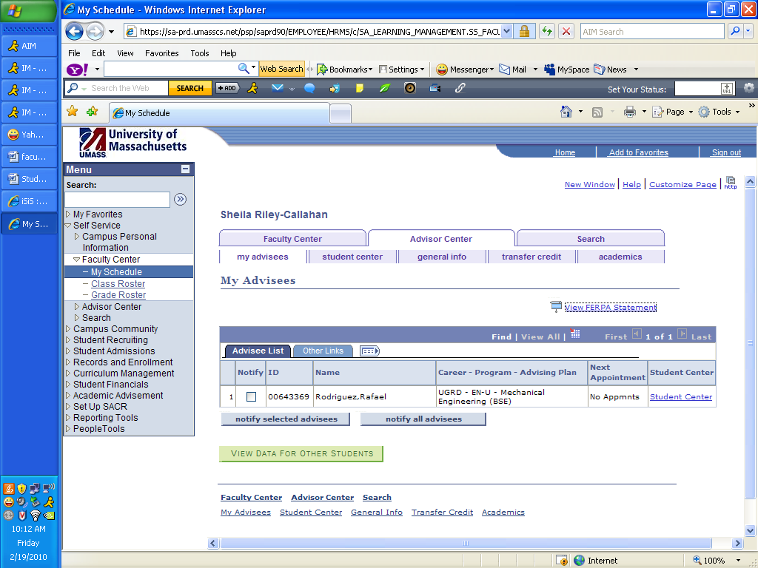

Please note: if you would like to email one or two of your advisees, click ‘notify selected advisees.’ If you would like to email all of your advisee’s, click ‘notify all advisees.

How do I advise drop-in Students?

To advise drop-in students who are not your advisees you must click the yellow bar ‘View Data for Other Students.’ (Shown above)

How do my students find out who their advisor is?

When a student logs into ISIS the faculty Advisor’s name appears on the right hand side of their home page.

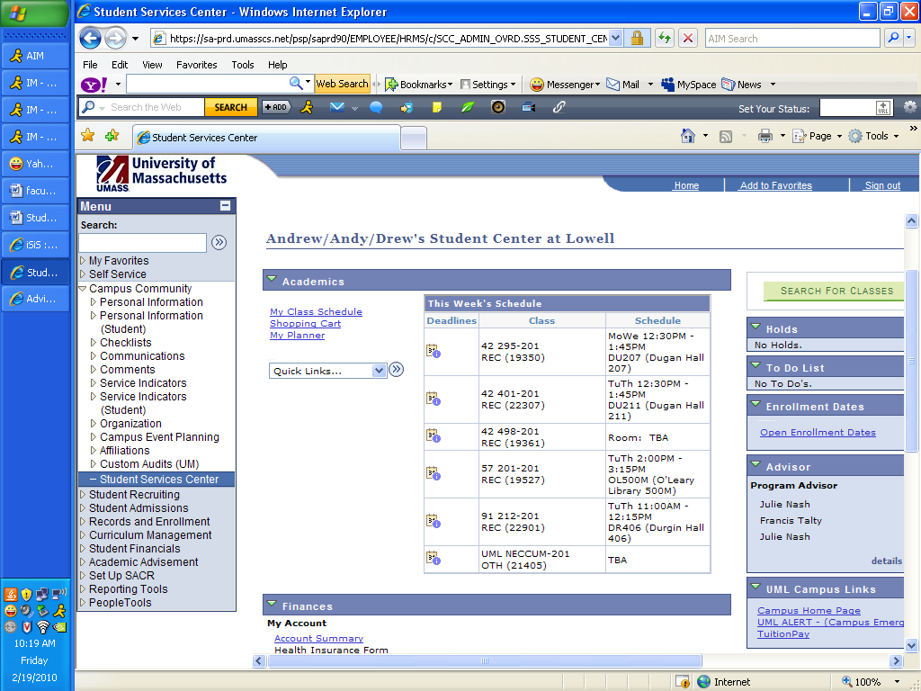

How often should I contact my advisees?

Generally it is good practice to send a welcome letter to your advisees at the start of the semester. If you are informed that a student is having problems, it is good practice to try to contact students. Beyond that there are departmental differences in the frequency of contact.
How many hours should I plan to spend on advising?

The contract recommends that faculty allocate 3 hours per week to advising. During the Advising period (lasting two weeks) 2 additional hours are mandated.

Can a student change advisors?

In most Departments students can contact the Department Chair and request a change of Advisor. This change can be entered in ISIS by the Department Chair or Administrative Assistant.

Transfer issues

How many credits are students permitted to transfer in to UML?

Students must meet a residency requirement of 30 credits to obtain a Bachelor’s Degree. Thus, no more than 90 credits can be transferred in.

No more than 60 credits can be transferred from a 2-year college. In special cases students may petition to bring in up to 72 credits from a 2-year college.

What should I do if I find an error in a student’s transfer courses?

Contact the registrar’s office or send an email to transfer@uml.edu. Describe what you believe is an error and the transfer office will contact the appropriate department chairs or the general education coordinator.
Student problems and referrals

How do I advise a student who is having trouble keeping up with class work and is having difficulty understand course content?

Call the Centers for Learning at 978-934-2936 and they will set the student up with a Peer Tutor or a professional staff person who can do some study strategies workshops with the student. For more information on how the Centers can help go to www.uml.edu/class

How do I advise a student who reports having a disability?

Email the Office of Student Disability Services; 978-934-4574; http://www.uml.edu/student-services/disability/default.html

How do I advise a student who reports having a personal crisis?

Email the Counseling Center: counseling@uml.edu ; 978-934-4331 http://www.uml.edu/student-services/counseling/default.html

How do I advise a student who reports a health issue?

Email Health Services: Health_Services@uml.edu; 978-934-4991 http://www.uml.edu/student-services/health/

How do I advise a student who reports some form of grievance, harassment or discrimination?

Notify your Department Chair or Contact the Office of Equal Opportunity and Outreach http://www.uml.edu/equal/default.html

How do I advise a student who is having problems regarding financial aid?

Notify the financial aid office. If the student’s concerns are not address, contact the Dean of Enrollment Management.

Academic policies

What is the FERPA policy and what are its implications in my dealings with students?

Student information is confidential. Information about biographical data, grades, status etc. should be shared only with your Department Chair or other University Officials on a need-to-know basis. The FERPA policy can be found at http://www.uml.edu/it/documents/FERPA_Info.pdf

What is the policy on academic forgiveness (deleting and/or repeating credits)?

Students who have transferred in less than 60 credits may delete or repeat up to 15 credits.

Students who have transferred in more than 60 credits may delete or repeat up to 7 credits

In order to delete or repeat credits a student must file an academic petition http://www.uml.edu/registrar/docs/academicpetition.pdf with the registrar’s office

Can students take courses in Continuing Education as part of their day-school tuition?

No they cannot.

What are academic petitions? How do they differ from exception forms?

Academic petitions are the forms used to make a request for a change in academic record or to make an exception to academic policy. Academic petitions can be downloaded from the Registrar’s website: http://www.uml.edu/registrar/docs/academicpetition.pdf

Academic petitions are used to implement changes to transfer credits. An approval on an academic petition becomes permanent. So, if a course is changed by academic petition, this change is entered into the transfer dictionary and is applied to all students attempting to transfer that course.

An exception form is a one-time exception. For example, if a particular advanced course enables students to waive 42.101, College Writing I, that would be a one-time exception. Exceptions relevant to general education must be approved by the general education coordinator.

Are there maximum or minimum numbers of credits students can take in a given semester?

Below 12 credits a student is considered “part-time.” This may affect the student’s financial aid or health insurance. Students should be advised of this before they are allowed to drop below 12 credits.

Students are prohibited from registering for course loads in excess of 20 credits unless such loads are required by established University curricula or unless special permission has been granted via academic petition.

How do students add a minor or change their major?

Students can file a change-of-major form, available on the Registrar’s Website. http://www.uml.edu/registrar/docs/declarationofmajor.pdf. Certain majors (nursing, engineering, etc) are not open to all and have entry criteria that have to be met.

Where are academic forms located?

Most academic forms can be found on the Registrar’s Website: http://www.uml.edu/registrar/forms.html.

Can students take courses at another college/university?

Before taking course off campus students should complete an Authorization for Off-Campus Courses form. http://www.uml.edu/registrar/docs/authorizationforoffcampuscourses.pdf
It is important to advise students that after they have completed 60 credits, they may not transfer in courses from 2-year colleges. (Some exceptions have been made for programs like American Sign Language, which are not offered at UMass Lowell).

What are the GPA requirements for graduating (major and university)?

The requirement for the overall GPA is a 2.0 cumulative average. The requirements for particular majors can be found in the undergraduate catalog.

What do warning, suspension, and dismissal mean?

A student whose semester GPA is below 2.000 is placed on Academic Warning. Although the student is not prevented from registerining or participating in coursework, the student is given notice that s/he is on probation.

A student who was on Academic Warning at the end of the previous semester and whose cumulative GPA falls below 2.000 is placed on Academic Suspension. The student may take a semester off and re-apply for admission after one semester. Alternatively, the student may appeal the suspension with the Dean of his/her college.

A student who was Suspended and whose cumulative GPA falls below 2.00 is dismissed from the University. The student may appeal the dismissal through the Provost’s office. The student may obtain “academic forgiveness” through the fresh-start program (which requires a 2-year hiatus from any coursework) or by obtaining an associate’s degree.

What is the difference between a DIG form? An advisement report? An official and unofficial transcript?

The DIG form indicates a student intention to graduate. The DIG form is generally filed within 90 credits of the proposed graduation date. When the DIG form is approved by the student’s advisor and department Chair the student is placed on a “Graduation” list.

The advisement report, which can be obtained through ISIS indicates what requirements the students has met toward his/her proposed degree and what requirements remain to be met.

The unofficial transcript provides a chronological record of all courses that a student has taken. It can be obtained through ISIS or through the registrar’s office. The official transcript provides a similar record but can only be obtained through the registrar’s office.

Where can you find a list of general education courses?
The general education courses are listed at the following website: http://www.uml.edu/gened/courses.html.

What are academic holds?

Academic holds are notations placed in a student’s ISIS record. In some cases (suspension, dismissal, unmet financial obligation, failure to immunize) an Academic Hold prevents a student from registering. Holds can be identified in ISIS under Advisees.

Student Opportunities

How does a student find out about study-abroad opportunities?

The study-abroad program is offered through the Center for Learning. http://www.uml.edu/class/Study_Abroad_Program/study_abroad.html

How does a student find out about internships or coop opportunities?

Internship and Coop opportunities are maintained within certain departments but they are also maintained by the Office of Career Services. http://www.uml.edu/student-services/Career_Services/Internships_and_Co-ops/Internships_and_Co-ops.html.

How does a student take the language placement exam?

The language placement exam is offered through the Department of Cultural Studies http://www.uml.edu/college/arts_sciences/culturalstudies/contact.html.

How does a student sign up for GRE or LSAT exams?

We are now offering preparatory workshops for the GRE, MTEL, LSAT and MCAT and GMAT in the Centers for Learning. Students can get guidance about signing up for these exams at the Centers for Learning on by going to the appropriate websites to get information on taking these exams.

