Step | Action
 | Logon to HR Direct Department Self Service: http://www.uml.edu/hrdirect
 | For User Account and Password use your complete email address, including @uml.edu, then choose Lowell Campus
Navigate to Department Self Service > ePAF Home Page>Start new ePAF
Click Change Employment Status.
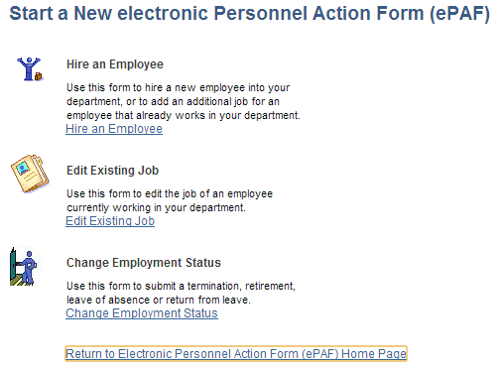
Update Form Data choosing appropriate Action/Action reason for the change.

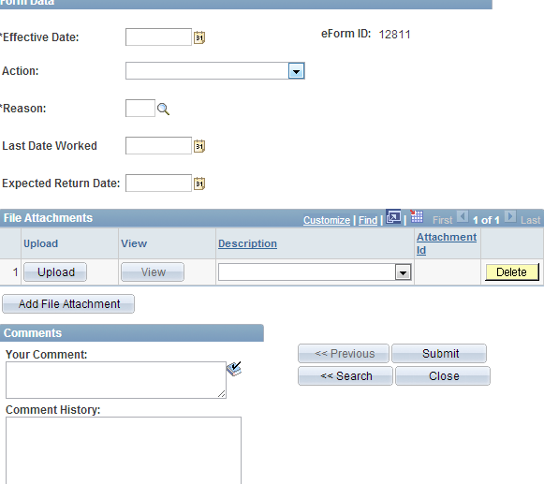
 | Click Submit
 | END PROCEDURE FOR JOB STATUS CHANGE.

