CAM Animation Scenario: Causal Feedback Loop in Thawing Permafrost
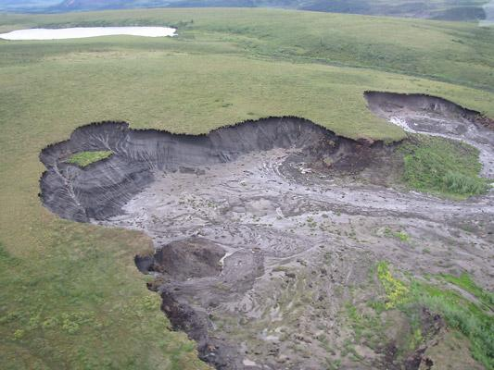
Figure 1 SEQ Figure \* ARABIC 1. Thawing permafrost soil. Credit K. Kennedy
Permafrost refers to a layer of soil or rock that is frozen all year round. Found throughout much of Alaska, parts of Canada, and other countries in the far north, permafrost contains the un-decomposed remains of hundreds to thousands of years of dead plant and animal remains. As the Arctic warms, some of this permafrost soil is thawing. As the permafrost thaws, microbes are able to decompose the previously frozen plant and animal remains. As microbes decompose this thawing organic material, they release carbon dioxide (CO₂) and methane (CH₄) into the air.

Carbon dioxide and methane are both greenhouse gases that trap heat in Earth’s atmosphere. Methane is a particularly powerful greenhouse gas - it traps about 84 times more heat than carbon dioxide on a per mass basis over a period of 25 years. Therefore, increased methane emissions from thawing permafrost is expected to cause further global warming. This additional warming can create a vicious cycle of thawing, decomposing and a warming atmosphere.

To learn more about permafrost, explore the following resources:
- Driven by climate change, thawing permafrost is radically changing the Arctic landscape, PBS Newshour
- How much worse will thawing Arctic permafrost make climate change? Scientific American.

