Before You Tape
Know how to get what you want for the final piece

Check your equipment.
Students should understand the camera that is available to them, including recording footage, controlling the zoom and focus, white balance if necessary, and sound. They should make sure the battery is fully charged and that audio recording is functioning before leaving the facility to film.

- Know your plan. Have it in writing.
Whether you require a script, a shot list or a story board OR all three students MUST have something in writing that helps guide what they are going to tape.
- Know how variety helps
There are a variety of images and shot types that can make your film more interesting.
Example: Extreme close up (ECU)
ECU allow us to see details. They are exciting, potentially emotional, and tension filled images. They don’t give you context or location.
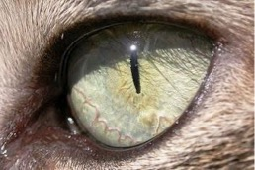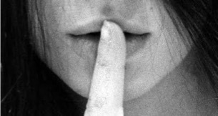
Example: Close up (CU)
CU helps you identify characters, emotions, and helps audience connect to the characters.
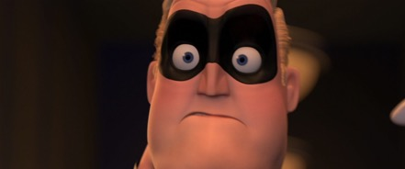
Example: Medium Shot (MS)
MS allows you to see action perhaps a tiny bit of the environment or setting. Medium shots are a great way to show relationships between people or between people and their immediate environment.
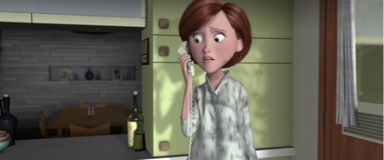
Example: Long Shot (LS)
LS allows you to see the context, location.
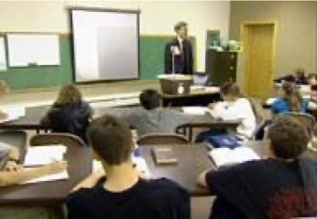
Example: Extreme Long Shot (ELS)
Also allows you to establish context, relationship between people, the direction a character is traveling. However, it does not show detail.
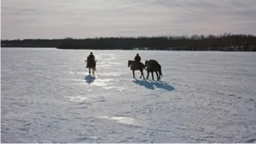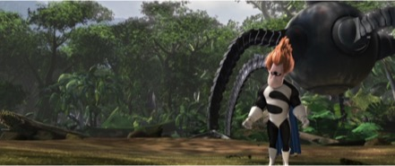
- Watch out for little mistakes such as a tilted camera or images out of focus.

- The rule of thirds.
Placing your object of interest on one of the lines that defines a third of the screen provides context and makes the shot more interesting and compelling. The rule of thirds creates balance, adds complexity, and makes the composition more dynamic.

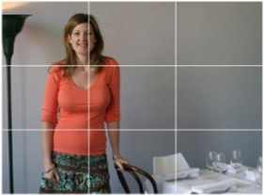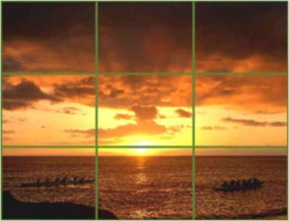
- Check your sound.
Microphones record sounds that we often don’t hear (or don’t pay attention to). For example, a kitchen is often the loudest room in a house because refrigerators make a lot of noise.
- Check sounds, using headphones
- Shoot in quiet locations
- Check the sound meter in the camera (make sure it’s not saturated or too low)
- Stop and listen to the sound around you (close your eyes)
- Record narration indoors if possible

- Pay attention to lighting.
Examples: Backlighting versus side lighting.
