Hello

There is an error on your timesheet for this pay period that needs to be reviewed and corrected by you.  Please log onto HR Direct and update your timesheet as needed.

Here is a list of the **most common mistakes** employees make on reporting time on your timesheet.

1. You entered *partial time* for a day but did *not report your total scheduled hours for that day*.

Entered incorrectly- total hours reported for the day are less than what was scheduled

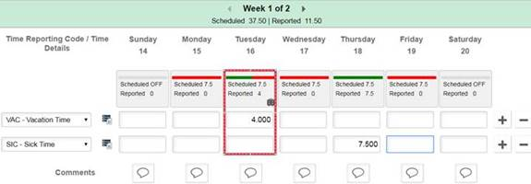

The time entry should be entered like this

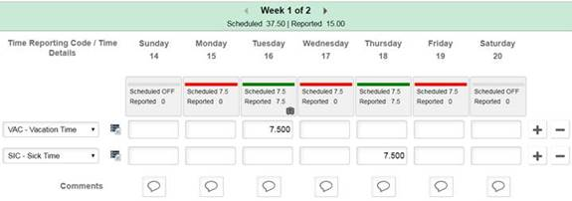

1. You reported time on a Holiday.  If you are scheduled to work that day the system knows it is a holiday.  No time entry is needed for this day and entering REG on a holiday is an error.

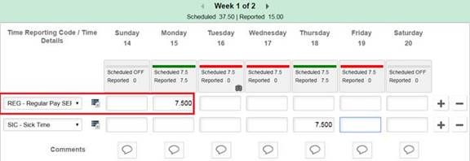

1. You used a Time Reporting Code that you are not authorized to use.  Refer to the HR Direct web page for applicable list of unauthorized Time Reporting Codes.

[Time Reporting Codes](http://www.uml.edu/HR/HRDirect/Time-Reporting-Codes.aspx)

1. Reporting hours greater than or less than the hours you were scheduled to work for the day.  The color coded bar is an indicator that the time reported is not in sync with the time that you were scheduled for.

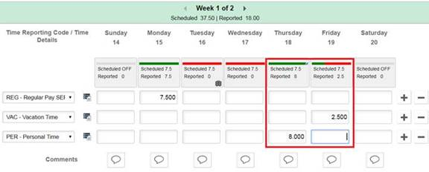

More information and training guides on reporting time in HR Direct are available at

[Job Aids and Training/Time Reporting And Approval](http://www.uml.edu/HR/HRDirect/Job-Aids-and-Training/Time-Reporting-And-Approval.aspx)