Updating Trusted Sites in IE
Note: If you are using Firefox, this browser does not offer a trusted site setting. You will be prompted for login credentials each time you access UMass-Summit through Firefox.

Step | Action
Begin by navigating to your IE browser menu.
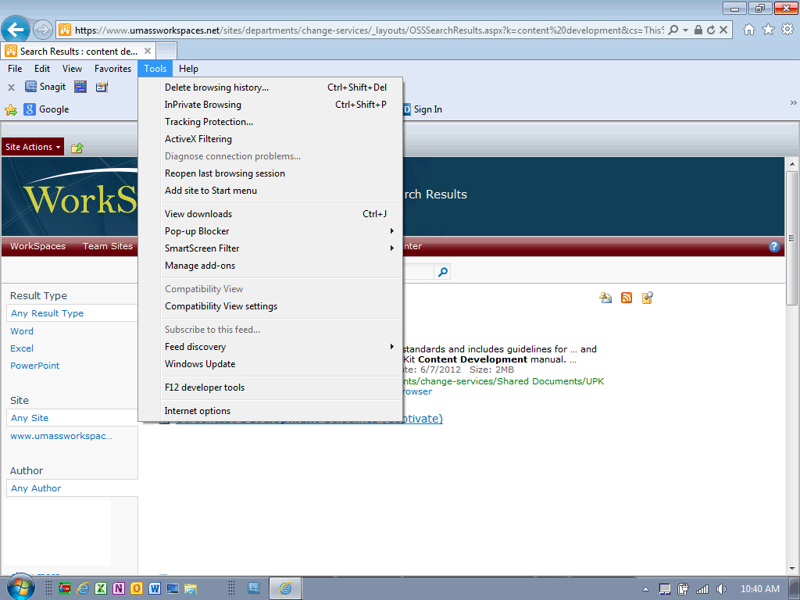

Click the Tools menu.
 | Click the Internet options list item.
Click the Security tab.
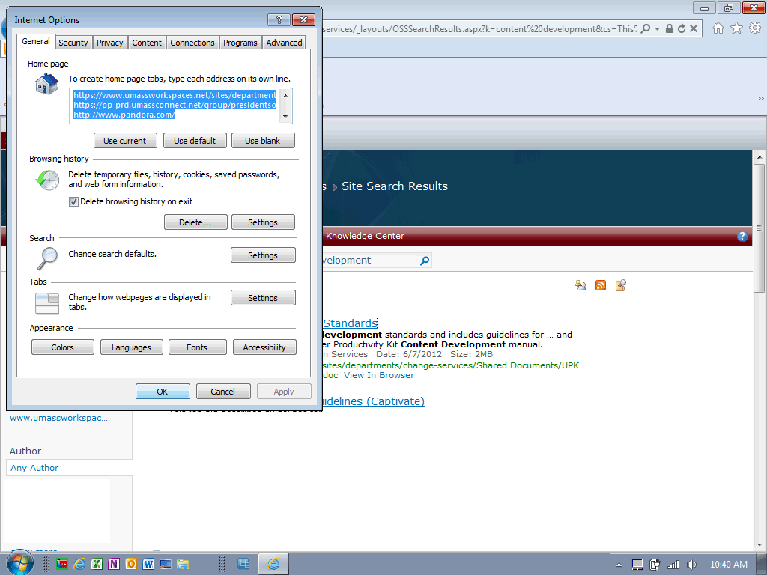
Click the Trusted sites link.
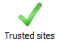
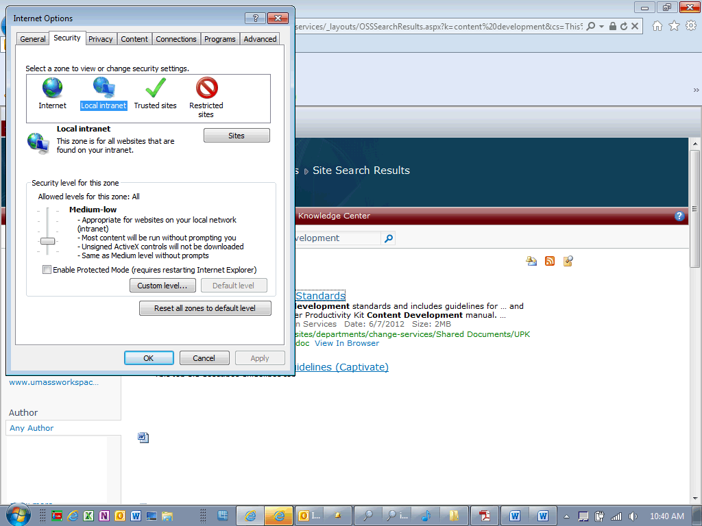
Click the Sites button.
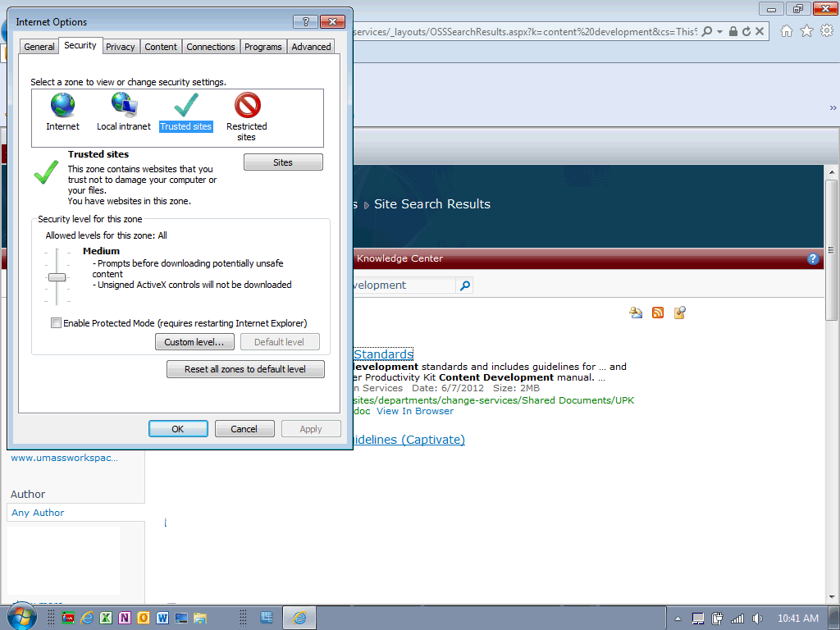
Enter the UMass Summit URL into the Add this website to the zone: field.

Enter a valid value e.g. "https://*.umass-summit.net".
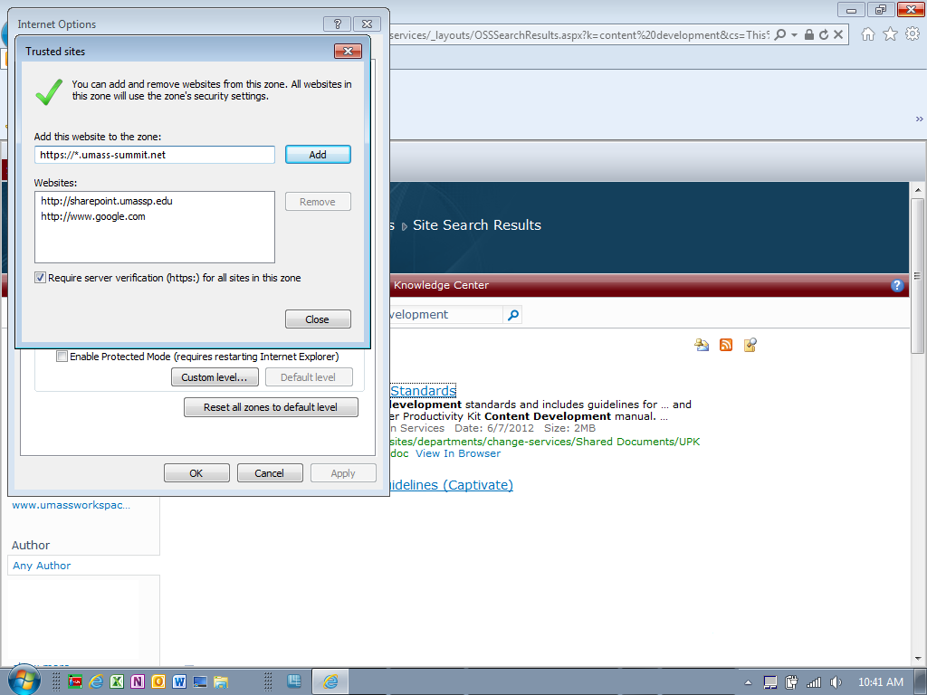
 | Click the Add button.
 | Click the Close button.
 | Click the OK button.
 | Congratulations! You have successfully updated your trusted sites. You may need to refresh your browser window.

