

Scholarship Award Request – JOB AID

Purpose:
To provide clear, step-by-step instructions for completing and submitting a Scholarship Award request. This request is used by departments to award scholarships using department funds and other allowable sponsored sources.

When to Use:
Use this request when requesting scholarship awards using a department’s chartfields and funds.

Requirements:
- Clear and complete description explaining the purpose of the request.
- Accurate chartfields.
- Supporting documentation (if applicable).
- Department approval.

Procedure

Step 1: Initiator Information
- Enter your name and contact information in the requestor section.
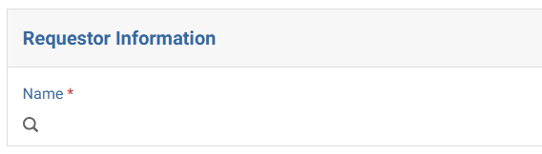

Step 2: Select Request Type
- Select “Scholarship - (Award Expense)” as the purpose of the journal request.
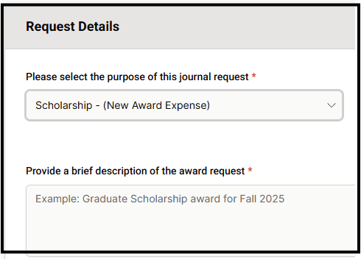

Step 3: Request Details

Confirm if award will be charged to a sponsored project.
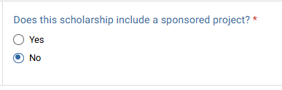
If you have more than 10 students, you can use and attach the scholarship template. Otherwise, complete the award information section below:
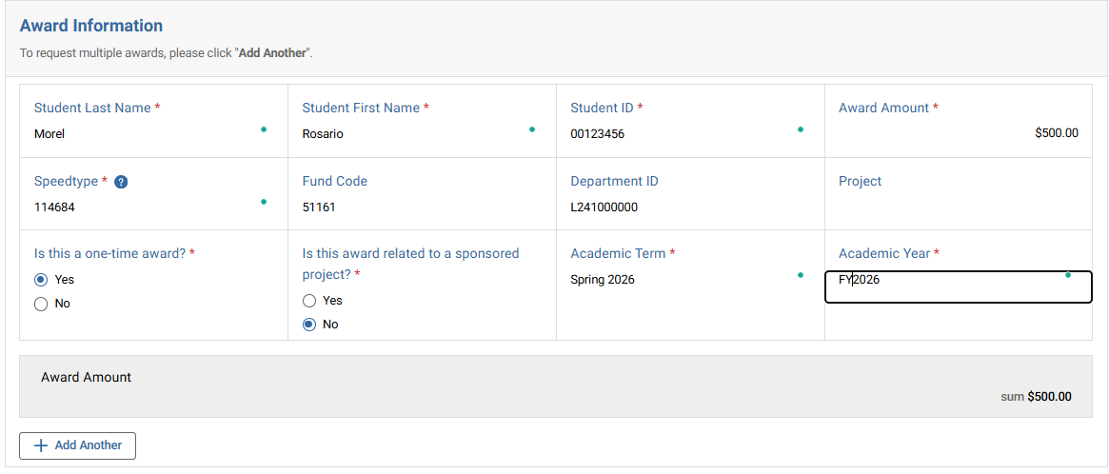

Step 4: Approver Assignment
- Add the appropriate Department Approver. If request involves a sponsored project, PI approval will be required.
- Ensure the designated approver has approval authority over the department receiving the expense.

Screenshot of described step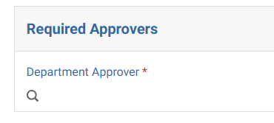

Common Errors to Avoid:
- Missing or vague descriptions
- Incorrect debit/credit direction
- Using the wrong chartfield
- Missing attachments
- Not assigning an approver

Best Practices:
- Write clear, audit-ready descriptions
- Double-check all chartstrings and amounts
- Ensure entries are balanced before submitting
- Attach all relevant supporting documentation

Controller’s Office to review:
- Proper use of funds and chartfields
- Accuracy of debit and credit entries
- Descriptions provided
- Supporting documentation
Requests may be returned if information is incomplete or unclear.

