University of Massachusetts Lowell

SiS 9.2 Upgrade

As of April 16, 2019, you will see the following changes to SIS.
Clearing Cache and Enabling Pop-Ups
After the upgrade, it is important that users clear your browser cache and also disable pop-up blockers before accessing the upgraded SiS Application.

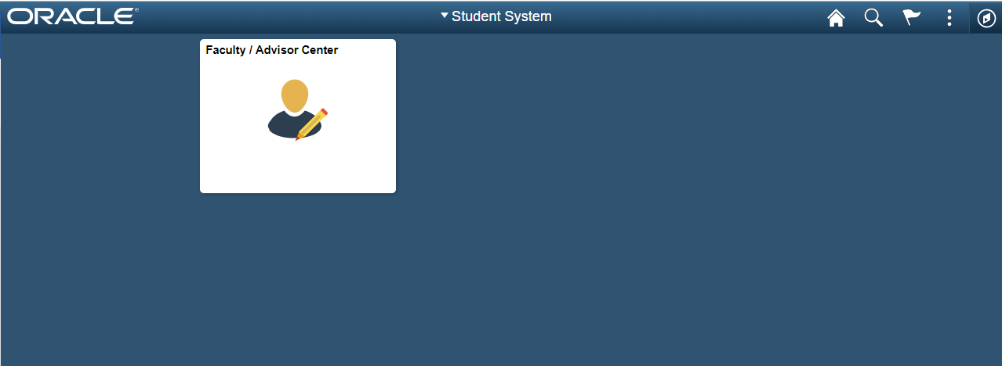

Tile

Home Button Global Search Notifications Actions List NavBar

Tile: Clicking on the Faculty/Advisor tile will bring you to the UM Faculty Center.
The small tab in the middle of the screen is used to toggle and hide the left-hand menu.

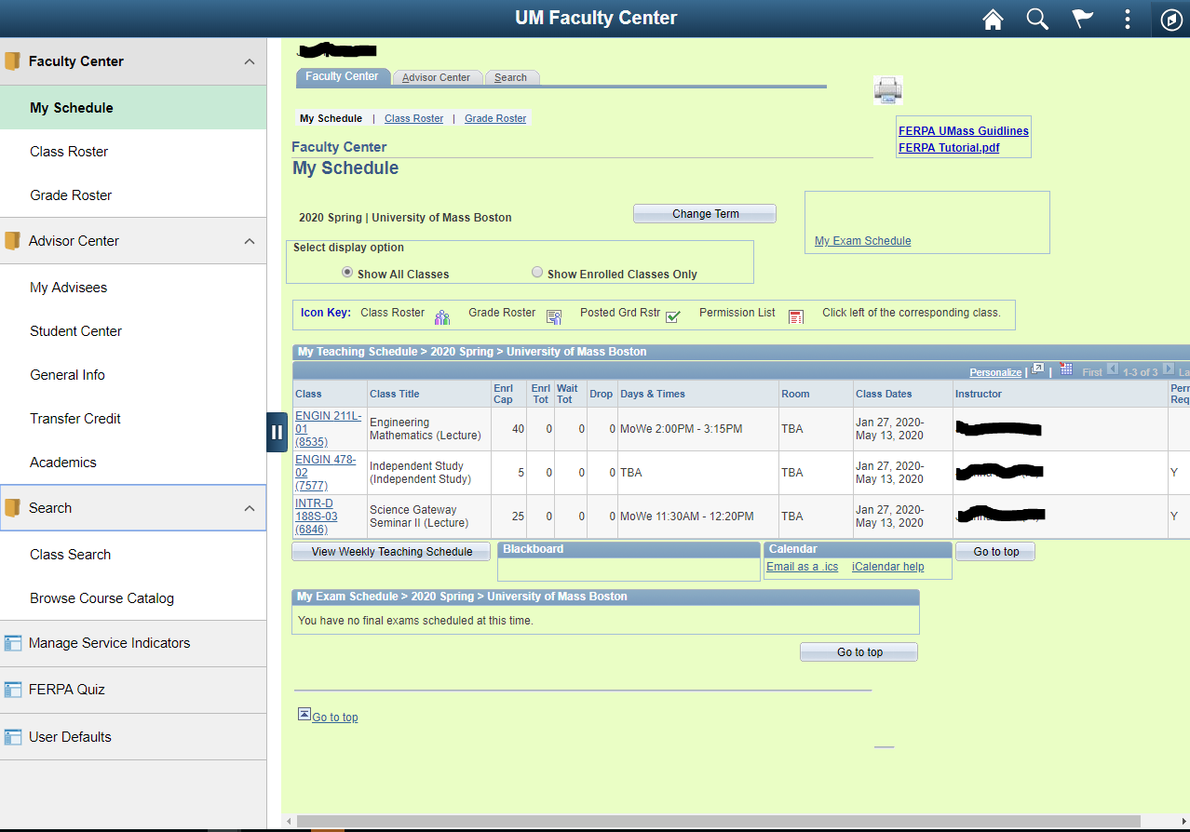 | 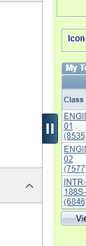

Home Button: From anywhere in SiS click on this button to return to the users Homepage.
Global Search: Global search functionality helps you search folders with the system. It will only bring up results if you have access to those modules or sections within SiS.
Notifications: Displays the notification window showing any pending actions or alerts. (Feature currently not being used by UMass)
Actions List: The Actions List button can be found at the top right of the page. This button allows users to perform specific actions while either on the Homepage or on a specific page
- From the Homepage, the Actions List button allows user to personalize their Homepage, change the settings through ‘My Preferences’, get help from Oracle through ‘Help’, or sign out of the account.
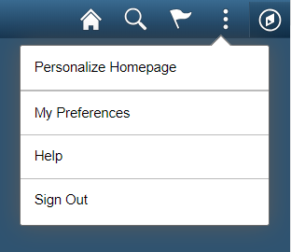

- If the user navigates to a specific page, the menu of the Actions List button will change. The user will now have the option to add the specific page to the Homepage, Navbar, or Favorites. The user will still have the option of changing settings and signing out.

NavBar: The Navigation Bar (NavBar) provides handy navigation options such as Recent Places, My Favorites, Navigator (which expands to show the Classic menu hierarchy), and My Preferences.
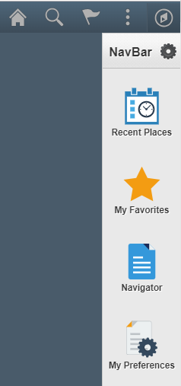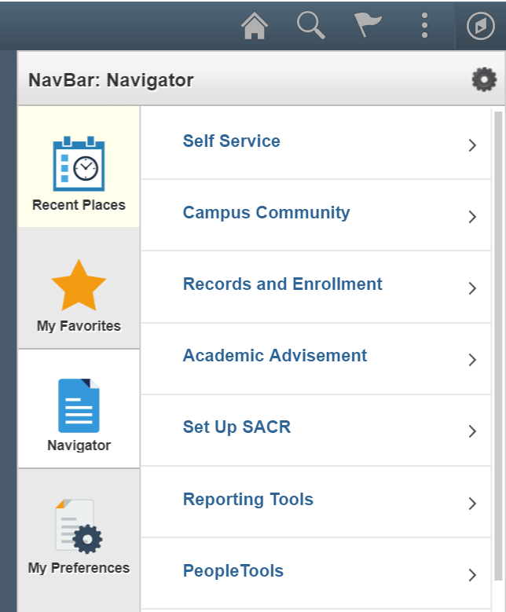

Navigator: It displays the traditional menu structure as the user would see when accessing SiS in classic mode and using the Main Menu. Users can navigate through the set of links just as you would using the Main Menu using classic SiS applications in the same order.

