Job Aid for Accessing DocuSign form with Single Sign On(SSO) using the Delegated Email/Resource shared account

When you receive an email notification from Docusign asking you to Review or Sign documents as in below:
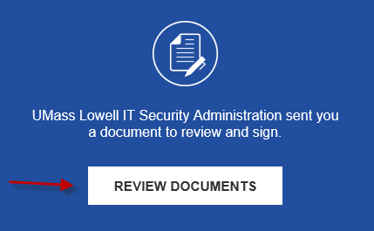

- Right Click on the Review Documents Button and choose Copy Hyperlink then paste the URL into an Incognito Browser in Chrome or a New Private Window in Safari/Firefox Browser.
- Logon using the Delegated Shared Email/Resource Account Email and Docusign Password setup when the account was added to Docusign workflow.

How to Create Incognito Browser in Chrome or a New Private Window in Safari/Firefox Browser.

Chrome - clicking on the 3 dots in upper right corner of browser and choose Incognito window
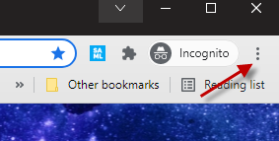
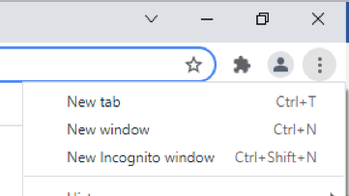

Firefox
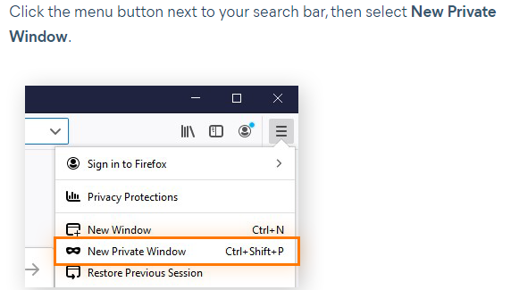

Safari
