Kimberly Ann Howell
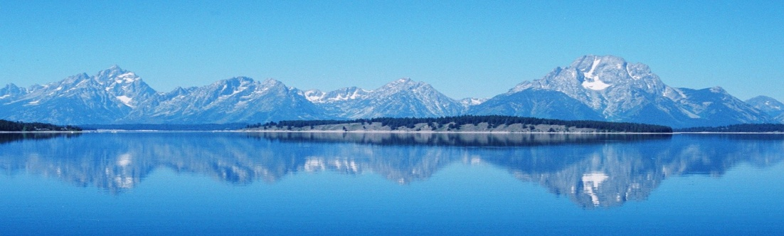
95 Prospect Street
Amesbury, MA 01913
(702) 461-3457
geologyxena@yahoo.com

EDUCATION: Ph.D. in Geological Oceanography, January 1999 – May 2005
Old Dominion University, Norfolk, VA
Dissertation title: Correlation and Causes of Fifth Order Cycles within the Bighorn Basin of Wyoming

M.S. in Geology
Old Dominion University, Norfolk, VA, August 1995
Thesis title: Late Cretaceous Foraminifera as Indicators of Sequence Boundaries, Book Cliffs, Utah, U.S.A. - Conducted under National Science Foundation Grant #NSF-EAR-9304422

B.S. in Geology\ Minor in Biology
Old Dominion University, Norfolk, VA, August 1992

Currently working on a Business Administration Degree with Southern New Hampshire University

Affiliations:
- Geological Society of America
- America Association of Petroleum Geologists
- National Speleological Society

EXPERIENCE:

Oil & Gas
Geology Discipline Manager, International Human Resources Development Company, 08/14 to present
08/14 – present Work with Subject Matter Experts (SMEs) to refine/update/create geology online e-Learning content and courses for the Oil & Gas Industry. Work with Instructional Designers to modify content into an appropriate e-Learning platform. This includes image design, animations and videos. Present geology related lectures for classroom courses.

Petroleum Geologist, BP Alaska, 07/12 to 06/14
07/12 – 06/14 BP Alaska Gravity Drainage Reservoir Management: responsible for stratigraphic framework and reservoir description for simulation modeling of fluvial and deltaic reservoir in Prudhoe Bay field. Duties also included geologic support for depletion plan projects, risk assessments and management plans.

BP Training Courses:
Subsurface Practices & Principles
Applied Subsurface Geologic Mapping
Subsurface Risk & Uncertainty Management
Stratigraphy and Reservoirs

Senior Petroleum Geologist, ExxonMobil, 1/08 to 06/13
1/11 – 06/13 ExxonMobil Exploration Company: Prospect geology of the Upper Cretaceous Piceance/Uinta Basin. Duties include utilizing Petra, Petrel and ArcGIS to generate play element, structure and isopach maps as well as cross sections to communicate potential prospects to upper management. Completed a play assessment that resulted in a 100 MOEB resource add for the company.

1/10 – 12/10 ExxonMobil Exploration Company: Conventional and unconventional play assessments for the Bighorn Basin utilizing ArcGIS. Results were used to define resource additions (50 MOEB for the conventional and 12 TCF for the unconventional).

1/09 – 12/09 ExxonMobil Research Company: Shale sealing capacity research utilizing proprietary and public rock property data. Research resulted in a classification system used by business units to incorporate into screening of potential prospects.

1/08 – 12/08 ExxonMobil Development Company: seismic interpretation of a major international asset during early production phase (Sakhalin 1). Duties included detailed seismic interpretation using GeoFrame and Petrel.

ExxonMobil Training Courses:
Flagship 1: Introduction to Subsurface Interpretation
Flagship 2: Fundamentals of Structural and Stratigraphic Concepts
Flagship 3: Formation Evaluation and Operations
Fine-Grained Mudstone School
Basic Clastic Facies
Commercial Overview
Field Safety Leadership
Play Assessment
Unconventional Play Assessment
Seismic Stratigraphy of Carbonates

Academic
Field School Instructor, University of Georgia, 2006, 2007, 2008, 2009, 2010, 2011, 2012, 2013, 2014 and 2015
Field instructor for geology field course (Field Camp) mapping areas in Colorado, Utah, and New Mexico. Responsible for evaluating student geologic maps, organizing field trips as well as developing and executing exercises related to the petroleum industry.

Assistant Faculty in Residence, University of Nevada Las Vegas, 1/05 to 12/07
Instructor for Geology, Geography and Natural Disaster lectures. Responsible for oral presentations and lectures, preparing and administering tests as well as evaluating student performance. Coordinator for Geology and Geography 101, responsibilities included managing TAs and content as well as dealing with student disciplinary issues that included cheating and conduct.

Adjunct Faculty, Old Dominion University, Norfolk, Virginia, 8/02 to 12/04
Instructor for Geology and Introductory Oceanography lectures and labs. Responsible for oral presentations and lectures, preparing and administering tests as well as evaluating student performance.

Adjunct Faculty, Tidewater Community College, Virginia Beach Campus, 1/00 to 12/04
Instructor for Geology and Introductory Oceanography lectures and labs. Responsible for oral presentations and lectures, preparing and administering tests as well as evaluating student performance. Conducted cruises on the R/V Matthew F. Maury and instructed students on the use of various oceanographic equipment.

Environmental
Field Geologist/Site Manager, IT Corporation (now Shaw Environmental), NC and VA, 1/96 to 5/98
Responsible for all aspects of field work which included supervising drilling projects, soil and groundwater sampling, remediation system installation and maintenance for up to 20 different sites.

ADDITIONAL EXPERIENCE: Proficiency with the following computer platforms and software:

Platforms: Software:
- Windows - Microsoft Office Suite - ArcGIS
- UNIX - Petrel - Tableau
- Macintosh - Petra - GeoFrame

PERSONAL: Enjoy the outdoors (hiking, biking, running, caving), challenging assignments

