

Fund Transfer Journal Request - JOB AID

Purpose:
To provide clear, step-by-step instructions for completing and submitting a Fund Transfer (Moving Funds). This request is used to move funds between departments, and it is processed by the Controller’s Office via journal entry.

When to Use:
Use this request when moving funds to another department or reallocating funds between departments.

Requirements:
- A clear and complete description explaining the purpose of the transfer
- Accurate chartfields
- Supporting documentation (if applicable)
- Department approval

Procedures:

Step 1: Initiator Information
- Enter your name and contact information in the requestor section.
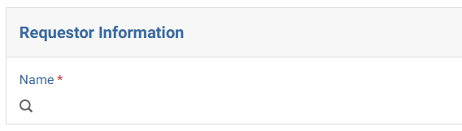

Step 2: Select Request Type
- Select “Fund Transfer - Moving Funds” as the purpose of the journal request.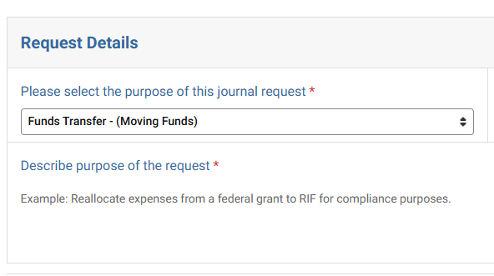

Step 3: Identify Fund Type
Confirm whether funds are being transferred to a general operating fund. General operating funds include: 51066, 51161, 52110, 51337.
If the fund receiving the transfer is one of the above, proceed by selecting “Yes”. If the destination fund is not one of the above, select “No”.
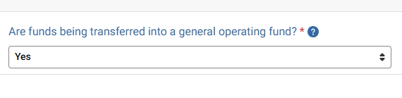

Step 4: Request Details – Fund Classification
- If transferring to a RIF account (Fund 52129) → Select Research Investments Funds (RIF)
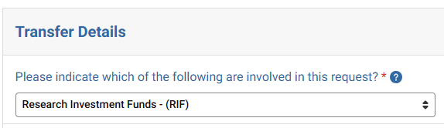

- For all other funds → Select General

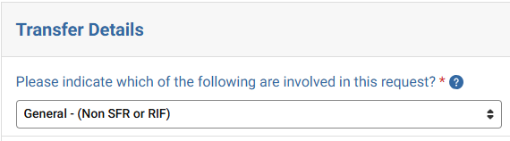

Step 5: UMass Cross-Campus Journal
- If transferring funds within UMass Lowell → Select “No”. Otherwise select, “Yes”
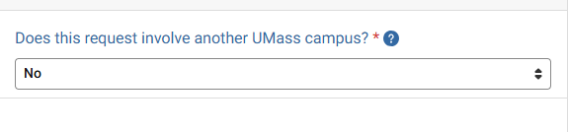

Step 6: If the department has a Speedtype
  - Select Yes
  - Otherwise select No
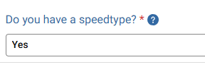

Step 7: Journal Entry Lines
Each transaction must include at least two lines: one Debit (+) line - One Credit (-) line.

Fund Transfer Rules:
- Debit (+) → Where the funds are coming FROM
- Credit (-) → Where the funds are going TO
- Provide Speedtype
- Provide a line description and the amount of the transfer.
- Line reference is optional

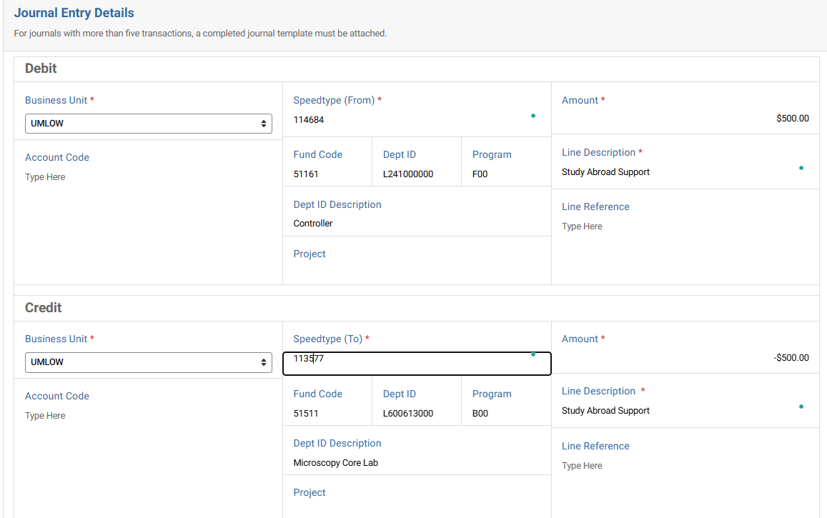

Step 8: Supporting Documentation
- Click “Select a file” to upload supporting documentation
- Examples include supporting calculations, email approvals, reports supporting the transfer, etc.

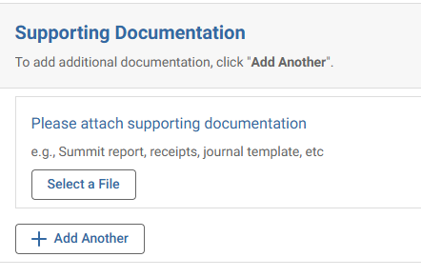

Step 9: Approver Assignment
- Add the appropriate Department Approver. If this is related to a sponsored project, PI approval will be required.
- Ensure the designated approver has approval authority over the chartfield transferring funds.
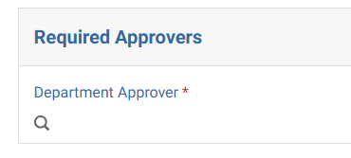

Common Errors to Avoid:
- Missing or vague descriptions
- Incorrect debit/credit direction
- Using the wrong chartfield
- Missing attachments
- Not assigning an approver

Best Practices:
- Write clear, audit-ready descriptions
- Double-check all chartstrings and amounts
- Ensure entries are balanced before submitting
- Attach all relevant supporting documentation

Controller’s Office to review:
- Proper use of funds and chartfields
- Accuracy of debit and credit entries
- Descriptions provided
- Supporting documentation
Requests may be returned if information is incomplete or unclear.

