

Cost Transfer Journal Request - JOB AID

Purpose:
To provide clear, step-by-step instructions for completing and submitting a Cost Transfer (Moving Expenses). This request is used to move expenses between departments and is processed by the Controller’s Office via journal entry.

When to Use:
Use this request when moving expenses from one department to another or when reallocating expenses between chartfields of the same area (same college, etc).

Requirements:
- A clear and complete description explaining the purpose of the transfer
- Accurate chartfields
- Supporting documentation (if applicable)
- Department approval

Procedures:

Step 1: Initiator Information
- Enter your name and contact information in the requestor section.
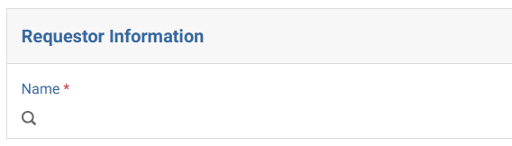

Step 2: Select Request Type
- Select “Cost Transfer - Moving Expenses” as the purpose of the journal request.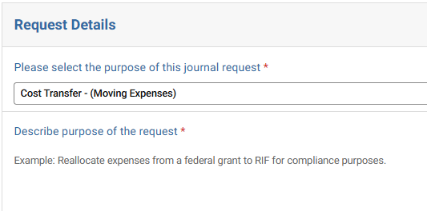

Step 3: Request Details – Expense classification
- Based on the chartfield and the expenses being reallocated, you will select from the following categories:
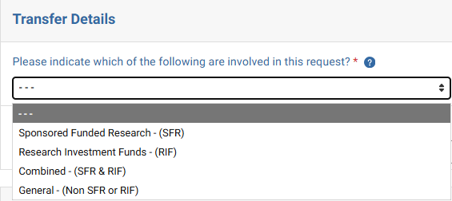
Select the appropriate category based on the accounts used in the reallocation:
- SFR: Choose this option if a sponsored project appears in either the debit or credit line.
- RIF: Select this option if fund 52129 code appears in any debit or credit line.
- Combined: Use this when the request involves both a sponsored project and an RIF account.
- General: Select this if none of the above conditions apply.

Step 4: UMass Cross-Campus Journal
- If transferring an expense within UMass Lowell → Select No. Otherwise select, Yes
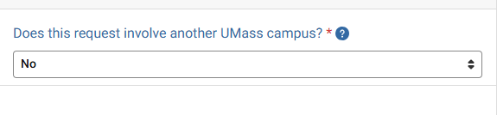

Step 5: If the department has a Speedtype
  - Select Yes
  - Otherwise select No

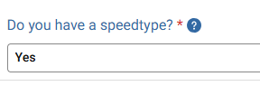

Step 6: Journal Entry Lines
Each transaction must include at least two lines: one Debit (+) line and one Credit (-) line.

Cost Transfer Rules:
- Debit (+) → Where the expense is Increasing
- Credit (-) → Where the expense is decreasing
- Provide Speedtypes
- Provide a line description and the amount of the transfer.
- Line reference is optional

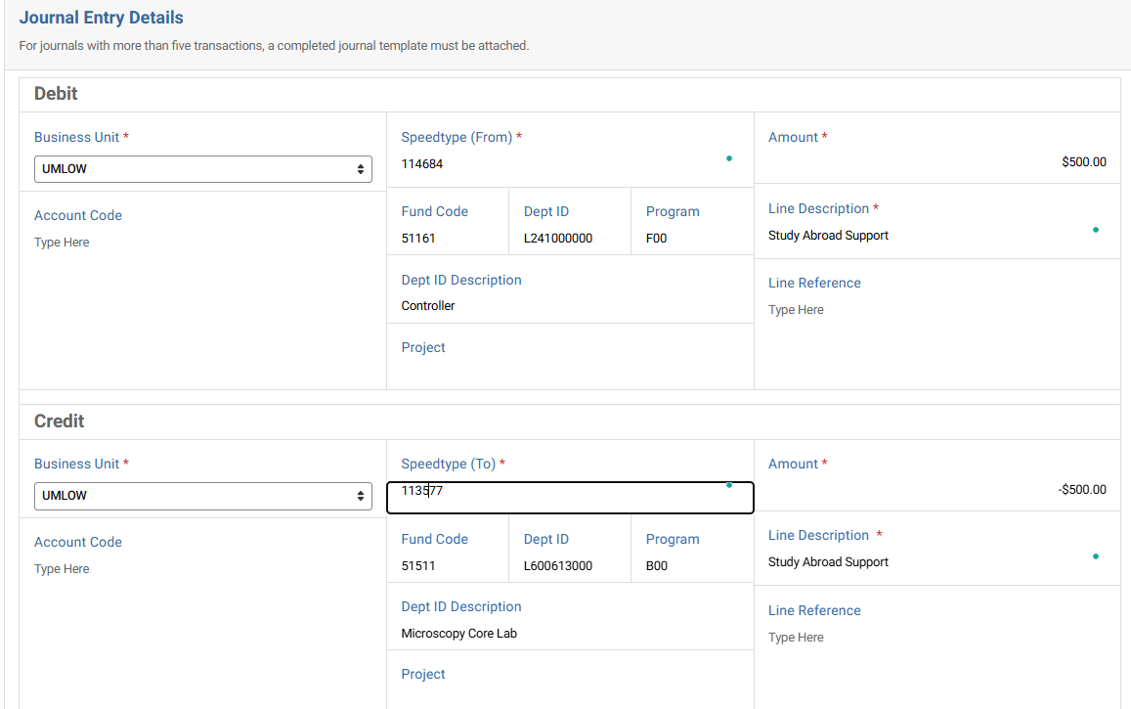

Step 7: Supporting Documentation
- Click “Select a file” to upload supporting documentation.
- Examples include supporting calculations, email approvals, reports supporting the transfer, etc.

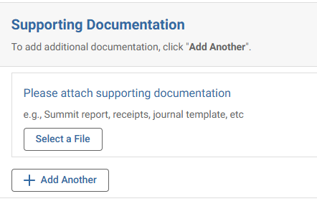

Step 8: Approver Assignment
- Add the appropriate Department Approver. If this is related to a sponsored project, PI approval will be required.
- Ensure the designated approver has approval authority over the department receiving the expense.
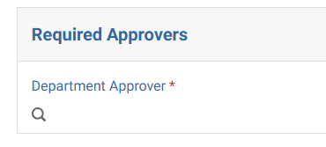

Common Errors to Avoid:
- Missing or vague descriptions
- Incorrect debit/credit direction
- Using the wrong chartfield
- Missing attachments
- Not assigning an approver

Best Practices:
- Write clear, audit-ready descriptions
- Double-check all chartstrings and amounts
- Ensure entries are balanced before submitting
- Attach all relevant supporting documentation

Controller’s Office to review:
- Proper use of funds and chartfields
- Accuracy of debit and credit entries
- Descriptions provided
- Supporting documentation
Requests may be returned if information is incomplete or unclear.

