

Chargeback-Internal Billing Request - JOB AID

Purpose:
To provide clear, step-by-step instructions for completing and submitting a Chargeback-Internal Billing request. This request is used to pay back IT for equipment and police invoices. Payments are processed by the Controller’s Office via journal entry.

When to Use:
Use this form when paying a police invoice or paying IT by journal entry.

Requirements:
- A clear and complete description explaining the purpose of the transfer
- Accurate chartfields
- Supporting documentation (if applicable)
- Department approval

Procedures:

Step 1: Initiator Information
- Enter your name and contact information in the requestor section.
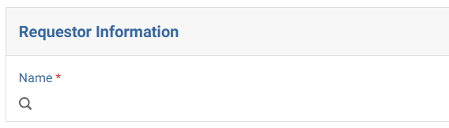

Step 2: Select Request Type
- Select “Chargeback-Internal Billing” as the purpose of the journal request.
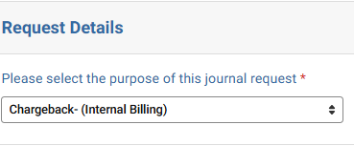

Step 3: Request Details

Confirm if chargeback involves a sponsored project.
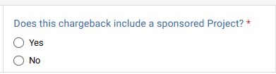
- Select the type of chargeback being submitted. For computers or accessories, select “IT Chargeback”. To pay a police invoice, select “Police Chargeback”.
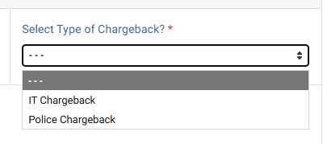

Step 4: IT Chargeback
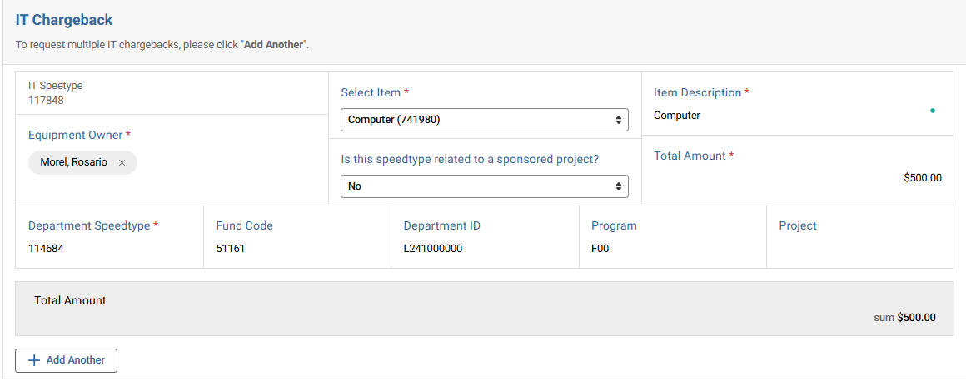

- Enter the Equipment Owner (the individual the equipment is being purchased for)
- Indicate whether the item is a computer or an accessory.
- Provide a clear item description.
- Confirm if the chargeback involves a sponsored project.
- Enter the total amount.
- Enter the speedtype that will be used to pay for the equipment.
- Click “Add Another” if multiple chargebacks are needed.

Step 5: Police Chargeback
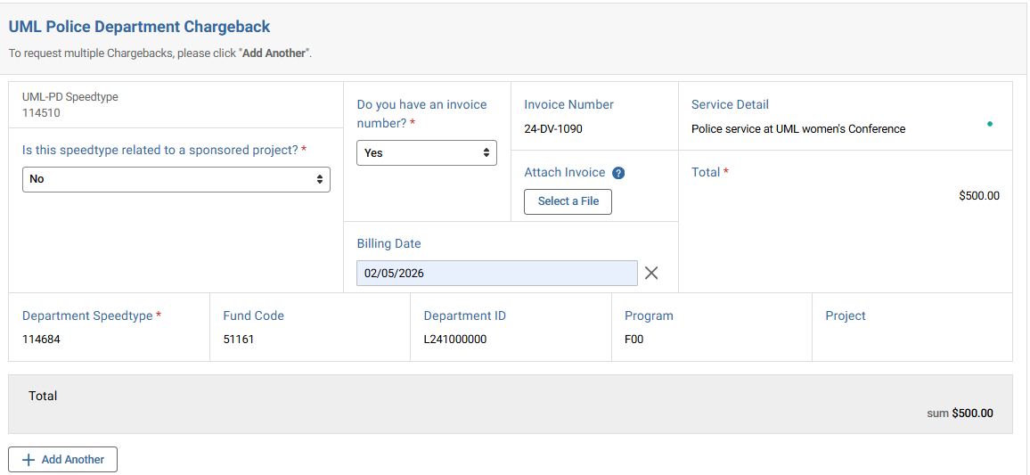

- Indicate whether transaction relates to a sponsored project.
- Select whether you have an invoice number and enter it if applicable.
- Attach the invoice using “Select a File.”
- Enter a clear description of the services provided under “Service Detail”.
- Input the total chargeback amount.
- Enter the billing date.
- Enter the speedtype used for paying the invoice.
- Review the total to ensure it matches the invoice.
- Click “Add Another” if multiple chargebacks are needed.

Step 6: Approver Assignment
- Add the appropriate Department Approver. If request is related to a sponsored project, PI approval will be required.
- Ensure the designated approver has approval authority over the chartfield receiving the expense.

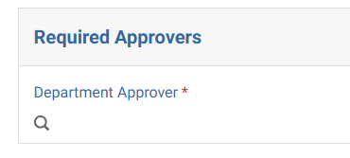

Common Errors to Avoid:
- Missing or vague descriptions
- Incorrect debit/credit direction
- Using the wrong chartfield
- Missing attachments
- Not assigning an approver

Best Practices:
- Write clear, audit-ready descriptions
- Double-check all chartstrings and amounts
- Ensure entries are balanced before submitting
- Attach all relevant supporting documentation

Controller’s Office to review:
- Proper use of funds and chartfields
- Accuracy of debit and credit entries
- Descriptions provided
- Supporting documentation
Requests may be returned if information is incomplete or unclear.

