Miniprojects
Solar Systems Engineering 22.527(web-based course)
U Mass Lowell
March 14, 2007
John Duffy, Instructor

The overall goal of the miniprojects is to provide you with a chance to apply the theory and tools of solar engineering to an actual system and an opportunity to help communities, local and remote. This is a service-learning project in which academic goals are met along with real community needs. There are two projects described below. You have your choice of either one, but inform the instructor before March 26 for final approval of group members (two folks per group) and project.

U Mass Lowell students have for the last nine years been working with residents of small remote villages in the Andes mountains of Peru. Background information on the project is available at http://energy.caeds.eng.uml.edu/Peru/index.shtm. The inhabitants of most of these villages, along with more than 1.6 billion other people in the world, have no electricity from the grid and, along with more than a billion people, have no clean water. We have designed and installed photovoltaic systems in about 20 medical clinics to provide power for vaccine refrigeration, radio transceiver communication, and lights; in schools for computer usage; and in towns for solar water pumping and purification. A table below indicates the systems installed.

A. Design water pumping systems without batteries for villages in the Peruvian Andes

Solar water pumping and pasteurization and UV and sand filter water purification systems have been designed and installed in some towns. And we have been having difficulties with some of the pumps failing. We would like to analyze and redesign these systems. Also we need a design for a new water pumping system in the town of Laguna. Laguna is located just below Quillapampa in Figure 1.

We have about three years of hourly weather data from our own data logger in the clinic in the town of Raypa, 1400 m elev. 9.6500° S, 77.9170° W (coordinates courtesy of http://www.heavens-above.com ). It is in the same time zone as Lowell. Also we have data from Malvas, 3100 m elevation, 9.9170° S, 77.6830° W and from Cochapeti (9.9830° S, 77.6500° W, 3400 m).

The water supply system in Huayash has four 50 W PV modules and two 140 Ah storage batteries. Huayash is roughly 20 miles down stream from Raypa. Water is pumped from the river to a tank on a tower above the town. We are definitely planning to modify this system in June.

Objectives: The technical objectives include:

- Estimate the monthly average irradiation for each month at the location for one year incident on the PV modules. Extrapolate your estimates from Raypa to Laguna. You can assume that the slope of the PV modules is ten degrees tilted toward the equator (that is, facing true north).
- Measure the Isc and Voc of at least two of the Evergreen 50W modules that are in the solar lab (E405) along with the module temperature and incident solar irradiation on a sunny day outside with the module normal to the sun. There is a DVM with a thermocouple attachment along with a pyranometer (courtesy of the solar club) in the lab. Do they meet the specifications of the module? (Thanks to Evergreen for donating the modules; they may not meet the specifications since they are gifts, so we need to check them out. Please mark the modules with masking tape on the edge so we know which ones you tested.)
- The existing systems use 12 V dc as the system voltage. Use the following estimated loads: enough energy to pump 500 l of water for the people in the town with a pump to an estimated height of roughly 20 m to the top of the small hill adjacent to the town (head, including the effect of friction) (Shurflo 2088-414-734, 12 VDC, http://www.shurflo.com, pump has been used in several of our systems). There could be a maximum power point tracker. You will need to develop a mathematical model of the motor startup and how the motor interfaces with the PV modules. There should be enough background material in the class notes.
- Sketch the wiring diagrams of the system. Assume 20 ft. of wire from the PV to the pump. Specify wire gauge to limit power loss in the wires to 3%.
- Perform an hourly simulation of the system with your estimated hourly solar irradiation and ambient temperature for the worst month. Keep track of loss of load and summarize it for the month.
- Discuss the advantages and disadvantages of the system without and with batteries in terms of estimated cost, reliability, and environmental impact.

B. Estimate the yearly power output from all our PV systems in Peru for possible carbon offset purchase by Staples.

Background: Last Friday (3-9) I was on a panel at MIT for the Solar Decathlon Team. On the panel with me was the VP for Environmental Affairs for Staples. He offered that Staples could buy carbon offset credits from our solar systems in Peru. So it occurred to me that a really nice miniproject for the 22.527 course would be to estimate the number of kWh per year that our PV systems produce and the relevant amount of carbon offset per year. A table with the installed systems in Peru is given in the appendix. One group can do the valleys linked to the Casma hospital and another group can do the valleys linked to the Huarmey hospital.

Objectives:

1. Estimate the incident irradiation by month for each of the installations, based on the data from our own data logger systems (details below). Assume that the tilt is 10 degrees north toward the equator.

- You should also do the tasks listed under objective 2 in Miniproject A above to get a little experience testing PV modules.

- Estimate the actual electricity produced in kWh by month. Note that this may be more involved than one might think at first because the amount produced is not necessarily equal to the incident irradiation times the efficiency. It depends on the load. I think we can make the following assumptions: radios and lights are used about two hours a day. The input power to the radios is about 2.5 times the rated output power. There should be data enough to estimate the input energy to the fridges. I would recommend using Google Earth (free software) to locate the appropriate villages.

- Then estimate the carbon offset (i.e., the avoided CO2). You may have to do some background research on what is acceptable to use for this estimation. Then estimate the dollar value of that offset for a typical year, or better yet for the years for which we have actual solar data.

Details: The data from the Raypa site includes the following measurements by column: “1” designates hourly data, day number, hour, irradiation (W/m2), fridge current (A), PV current (A), battery voltage (V), temperature inside clinic (C), temperature ambient (outside) (C), temperature in fridge (C), internal battery voltage (V).

The data from the Malvas site includes the following measurements by column: “1” designates hourly data, day number, hour, battery voltage (V), PV voltage (V), battery current (A), load current (A), temperature inside fridge (C), temperature inside clinic (C), temperature inside clinic (C), irradiation (W/m2), internal battery voltage (V).

Data from the Cochapeti site includes the following measurements by column: “1” designates hourly data, day number, hour, irradiation (W/m2), fridge current (A), PV current (A), battery voltage (V), temperature inside clinic (C), temperature ambient (C), temperature in fridge (C), rain (inches), wind (mph), internal battery voltage (V).

The irradiation readings are taken with an SPLite pyranometer from Kipp and Zonen in a horizontal position on the roof of the clinics. Missing or corrupted data is denoted by “-6999” or a similar large negative number. Radio signals from the clinics introduced noise from time to time with some “-6999” data resulting. Temperatures are read with AD590 integrated circuit sensors. Currents are read with precision resistors, and voltages with voltage divider circuits. Sensors are scanned every second, and averages kept and recorded for each hour. Eric Morgan and Nick McGuire last year for the 22.521 course filtered the data and entered it into a spreadsheet. Note that some of the data might be still be in error, so I would suggest graphing the data over time and looking at it for reasonableness. I will forward the original and filtered data separately to the groups; just ask for it.

The learning objectives include in addition to developing skills in meeting the technical objectives, evaluating in part the potential sociological impact of solar technology on the community resulting from your participation in this project as a "citizen of the world." Very briefly summarize your estimates of projected impacts (health, economic, environmental) on the village of your recommended system improvements.

Deliverables: Your job is to meet the objectives above and to document them in a brief report. You are to include in the report your methodology (with any equations you use in your analysis) and then results and conclusions and recommendations. Teams of two are required. The final report with all the tasks is due May 11.

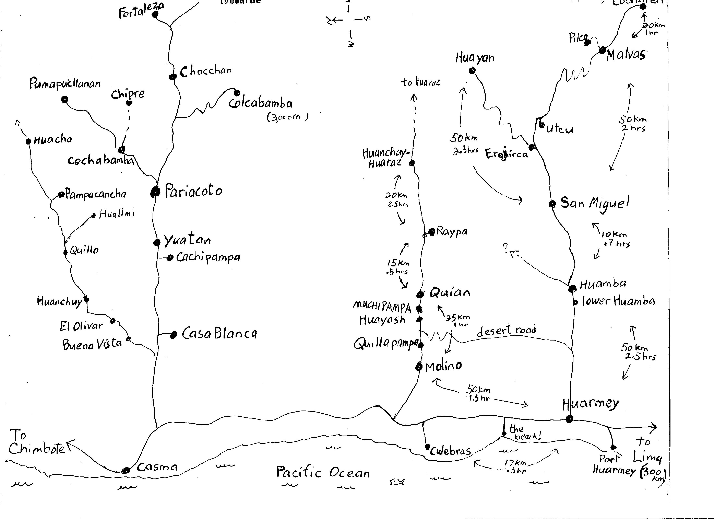

Figure 1. Map sketch of the locations of many of the villages we have systems in (courtesy of Janice Kurkoski).

Appendix.

UMass Lowell Village Empowerment Peru Project Installations as of January, 2007
Location | PV | Controller | Fluoresc. | Exam light | Battery |  | Lanterns, PC
Clinics:
Malvas | 50 W-ASE | 12. A | 20W | 10 W | 115 Ah |  | 2, PC, printer
Cochapeti | 100 W-ASE | 12. A | 2-20 W | 5 W | 195 Ah |  | 2, 2 PCs
Huayan | 40W | 10. A | for radio |  | 140 Ah |  | PC
San Miguel | 60 W-Sol | 12. A | 20 W, 18 W | 5 W | 115 Ah |  | 2, PC
Huamba | 150W-ASE | 30. A | 3-20W, 18W | 2-10 W | 250 Ah |  | 1, PC
Molino | 170 W-ASE, Sol | 30 A | 20 W | 5 W | 115 Ah |  | 1, PC
Quian | 100 W-ASE | 30 A (fridge & all share same batteries) | 3-20 W | 10 W | 230 Ah |  | 2, PC
Raypa | 100 W-ASE | 30 A | 2-20 W | 10 W | 230 Ah |  | 1, PC, printer
Colcabamba | 50 W ASE | 15 A | 15 W Edison |  | 120 Ah |  | 2, PC
Cochabamba | 100 W AstroPower | 20 A |  |  | 140 Ah |  | 1, PC
Chipre | 100 W AstroPower | 30 A | LED, 11 W Lumina |  | 140 Ah |  | 2
Fortaleza | 100 W Evergreen | 15 A | 18 W Lumina |  | 140 Ah
Pumapucllanan | 100 W AstroPower | 12 A | 15 W |  | 140 Ah |  | 1, 1 fridge
Gramita | 100 W Evergreen | 15 A | 15 W Edison |  | 140 Ah
Huacui | 80 W Arco 53 | 30 A | 2-15 W Edison |  | 125 Ah |  | Headlamp
Huallmi | 150 W | 30 A | 15W Edison |  | 260 Ah |  | Fridge
Schools:
Malvas School Sta. | 100 W-ASE | 10. A | for charging batteries
Malvas School | 110 W-Sol | 12. A | 20 W |  | 140 Ah |  | laptop PC, printer
Raypa School Station | 200 W-Siemens | C30 | for charging batteries
Raypa School | (shared array) | 30 A |  |  | 140 Ah |  | laptop PC, printer
Cochapeti School Sta. | 150 W-ASE  40 W Siemens | C30 A | for charging batteries
Cochapeti School | (shared array) | 30. A |  |  |  |  | laptop PC
San Miguel | 50 W ASE, 50 W Evergreen | 12 A |  |  |  |  | 2 laptops, printer
Pilco | 60 W Sol | 10 A | 11 W fluor. |  | 140 Ah |  | laptop PC
Huamba Baja | 50 W AstroP | 6 A |  |  | 140 Ah |  | laptop PC
Erajirca | 50 W AstroP | 10 A |  |  | 140 Ah |  | laptop PC
Quian | 80 W Siemens | 10 A |  |  | 140 Ah |  | laptop PC
Town Government: | PV/hydro | Controller |  | Lights | Batteries |  | Equipment
Quillapampa | 150 W Evergreen | C 12 |  | Sand filter | 140 Ah |  | water pump
Utcu | 150 W | C 12 |  |  | 140 Ah |  | water pump
Muchipampa | 120 W | 20 A |  |  |  |  | water pump
San Miguel hydro | 1400 W gen. | 20 A  Two C40, 48V | 220 V ac inverter | 20 W | 4-140 Ah |  | town lighting
Quian UV H2O | 200 W PV-ASE | 20 A |  | UV 20 W | 3 – 120 Ah |  | water purification
Yanacaca | 100 W ASE | 20 A |  |  | 125 Ah |  | water pumping
Cochapeti town hall | 100 W | 12 A |  | 2 – 20 W fl | 140 Ah |  | lighting
Huayash | 200 W ASE | C12 |  |  | 2-140 Ah |  | water pumping; sand filter
Clinics: | PV for fridge | Controller | Battery | Parabolic Cooker | Other |  | Headlamp
Malvas | 200 W-ASE | 15 A | 320 Ah | 1 | H2O pasteurizer  vap. comp. fridge |  | 1
Cochapeti | 250 W-ASE | 30 A | 345 Ah | 1 | vap. comp. fridge |  | 1
San Miguel | 200 W Evergreen | 30 A | 420 Ah |  | vap. comp. frige |  | 2
Huamba | 150 W ASE | 30 A | 220 Ah | 1 | vap. comp. fridge |  | 1
Molino | 150 W Evergreen, 50 W Solarex |  |  | 1 |  |  | 1
Quian | 200W-ASE | 30 A | 415 Ah |  | vap. comp. fridge |  | 1
Raypa | 200 W-ASE | 30 A | 420 Ah |  |  |  | 1
Churches |  |  |  | Lights
Malvas church | 50 W | 12 A | 140 Ah | 2-20 W fl. lights
Quian church | 50 W | 12 A | 140 Ah | 2 – 20 W fl
Malvas school dorm | 50 W ASE | 12 A | 140 Ah | 4-20 W fl. Lights
San Miguel parish house | 50 W | 12 A | 140 Ah | 2 - 20 W fl. Iight
Cochapeti church | 50 W | 12 A | 140 Ah | 3 – 20 W fl
 | Radio Systems
Clinic | Radio | Antenna | Emergency Hand Radio
Huarmey Hospital | 75 W | 13-element Yagi and vertical |  |  |  |  | 10 PCs
Malvas Clinic | 5+35 W | 4-element Yagi and vertical
Cochapeti | 5+35 W | Vertical | RadioShack
Huayan | 5 + 35 W | 13-element Yagi and vertical
San Miguel | 5 + 35 W | Vertical | Kenwood
Huamba | 5 + 35 W | 13-element Yagi | Kenwood, RadioShack
Quian | 5 + 35 W | 4-element Yagi and vertical | Kenwood
Raypa | 5 W + 30 W | 4-element Yagi | Radio Shack
Molino | 5 + 35 W | 13-element Yagi
Culebras | 50 W | Vertical and 4 element Yagi
Colcabamba | 5 + 35 W | 4 element Yagi
Cochabamba | 5 + 35 W | Vertical
Chipre | 5 + 35 W | 4 element Yagi
Pariacoto | 75 W | Vertical |  |  |  |  | 1 PC
Pumapucllanan | 5 + 35 W | 4 element Yagi
Fortaleza | 5 + 35 W | 4 element Yagi
Puerto Huarmey | 50 W Icom | Vertical
Chacchan | 75 W Icom | Vertical
Casa Blanca | 50 W Icom | Vertical
Huanchay | 5 + 35 W | Short wave
Victoria | 50 W Icom | Vertical
Pampacancha | 5 + 35W | 4 element Yagi
Quillo | 50 W | 4-element Yagi
Casma | 75 W | 13-element Yagi
Hunchuy | 50 W | 4 element Yagi
Huallmi | 5W + 35W | 4 element Yagi
Gramita | 5W + 35W | 4-element Yagi
Quillapampa | 5 W only
San Rafael | 50 W | Vertical
Micro-  enterprise: | Type | Equipment | Service
Malvas | Aquaculture trout | 1 cement pool | trout
Utcu | Aquaculture trout | 1 rock pool | trout
San Miguel | Aquaculture crayfish | 2 ponds | crayfish
Quian | Charging station | 50 W PV | headlamps
Fortaleza | Charging station | 50 W PV | lanterns/ headlamps

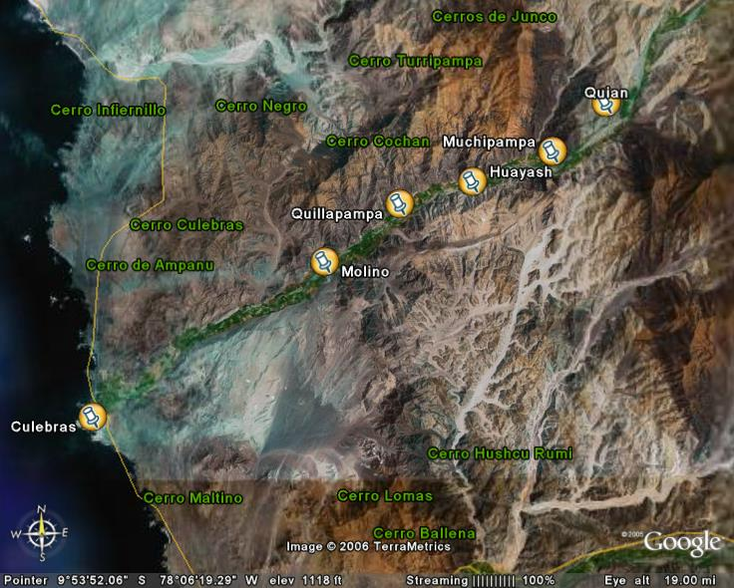
[The locations of towns in the Culebras Valley, courtesy of Kely and Google Earth]

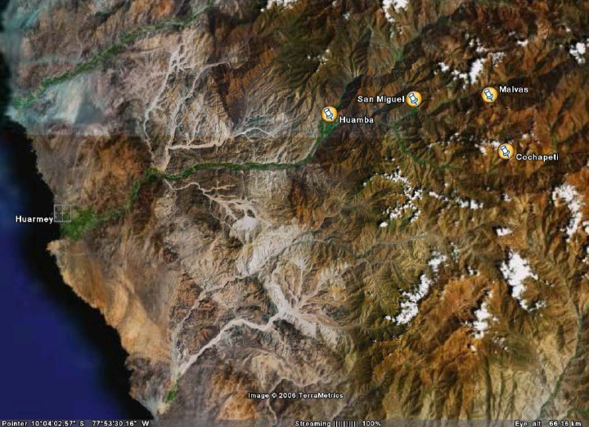
[Location of the some of our villages in the Rio Huarmey valley, courtesy of Marco and Google]

