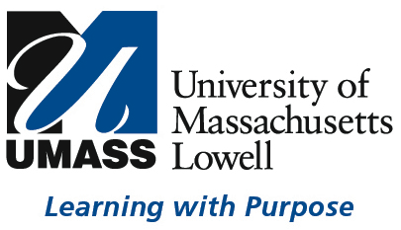

TASK FORCE ON SEXUAL HARASSMENT

WORKSHOP
Thursday, June 27, 2019
8:30am – 5:00pm
Alumni Hall Lounge

AGENDA:

- Welcome (8:30 – 8:45am) - Keith Mitchell

- Kim Pacelli, M.Ed. J.D., NCHERM (8:45am – 4:30pm)

Foundations of Compliance
Beyond Compliance – Best Practices
Support throughout Process
Role of Mandatory Reporters
Confidentiality versus Transparency
Changing Regulatory Landscape
Case Studies

- Sexual Harassment Task Force Next Steps (4:30 – 4:45pm)
  - Subcommittees – Assignments and Summer Work (Joanne Yestramski)
  - Update on Sexual Harassment Task Force Website (James Kohl)

- Subcommittee Breakouts (4:45 – 5:00pm)
  - Task Assignment - meet at least once over the summer
  - Define activities and timeline
  - Prepared to report at next full Task Force Meeting (September)

