Video/Photo Publication Release Form
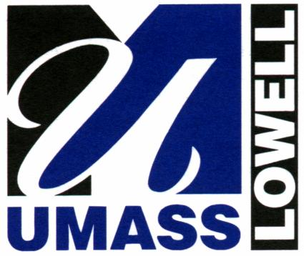
IRB No.:
Title of Research:
Date of IRB Approval:

All persons taking still photographs or videos for UML-related research publications must obtain a signed release form from anyone who is visibly recognizable in the photograph. Crowd scenes where no single person is the dominant feature are exempt. This form is intended for use with UML IRB approved research under the above noted IRB protocol.

PARTICIPANT CONSENT
I am 18 years of age or older and hereby grant the researcher designated below from the University of Massachusetts Lowell permission to photograph and/or videotape my voice and likeness and to use my voice and likeness in photograph(s)/video for publication for the above titled IRB approved research only. My name will not be used in any publication. I will make no monetary or other claim against UML for the use of the photograph(s)/video.

Name: Date:

Signature: ________________________________

If Participant is under 18 years old, consent must be provided by the parent or legal guardian:
Name: Date:

Signature: ___________________________________

UML RESEARCHER
Name: Date:
Address and Contact Information:

Signature: ___________________________________

